Project Design Phase
Solution Architecture

Date | 5 February 2026
Team ID | LTVIP2026TMIDS90862
Project Name | Prosperity Prognosticator: Machine Learning for Startup Success Prediction
Maximum Marks | 4 Marks

Solution Architecture:
Solution architecture defines the overall structure of the Startup Success Prediction system and explains how the business problem is addressed using technology. It connects the problem of startup uncertainty with a Machine Learning-based web solution. Its goals are to:
● Identify an effective Machine Learning model to predict startup success.
● Describe the structure and components of the system including the web interface, backend logic, and trained model.
● Define system features such as data input, preprocessing, prediction generation, and result display.
● Provide a clear framework for development, deployment, and integration using Flask and Scikit-learn.
Example - Solution Architecture Diagram:
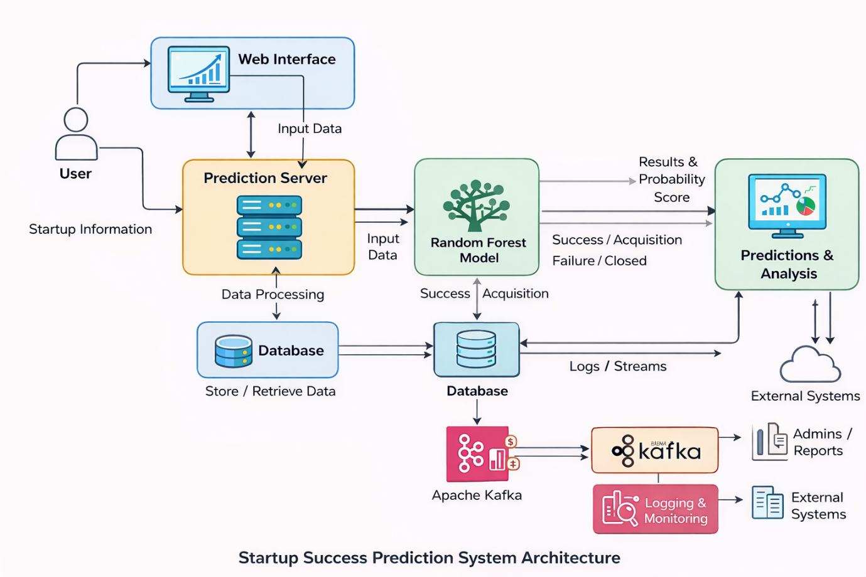
Figure 1: Architecture and data flow of the sartup success prediction

